OMNIA RETAIL POS
Point of sale, stock and billing system
Super Administrator Setup Guide
Company setup, store creation and access control

Prepared for: Super Administrator
Version 1.0 | 30 September 2026
Confidential — internal circulation only

Document control
Field | Detail
Title | Super Administrator Setup Guide
Version | 1.0
Date of issue | 30 September 2026
Prepared by | IT / Implementation team
Applies to | Omnia Retail POS — browser and Windows desktop application
Next review | On the next major release

Contents

1. About this guide
This guide covers the work that only a Super Administrator can carry out. A Super Administrator is not tied to any single store; the account sees every store in the company and owns the settings that stores are not allowed to change for themselves.
Follow the sections in order when setting up a new company or a new store. Once the setup in this guide is finished, hand the store over to its Store Administrator, who runs the day-to-day work described in the companion document, the Store Administrator Operating Guide.

Who does what
Area | Super Administrator | Store Administrator
Stores and storage locations | Yes | No
Terminals, numbering series, bill formats | Yes | No
Tax engine, HSN codes, payment methods, reason codes | Yes | No
Financial years | Yes | No
Products, customers, suppliers | Yes | Yes
Stock entry and billing | Yes | Yes
Creating cashiers and managers | Yes | Yes

Sign-in details
Use the account below. Change the password after the first sign-in.
Role | Email | Password
Super Administrator | prinsonsilvancardoza@gmail.com | prinson@123
Treat this account as a master key. It can reach every store's data, so it should stay with the implementation team and not be shared with store staff.

2. Signing in
Open the application in a browser, or start the Omnia POS desktop application, and enter the email address and password.
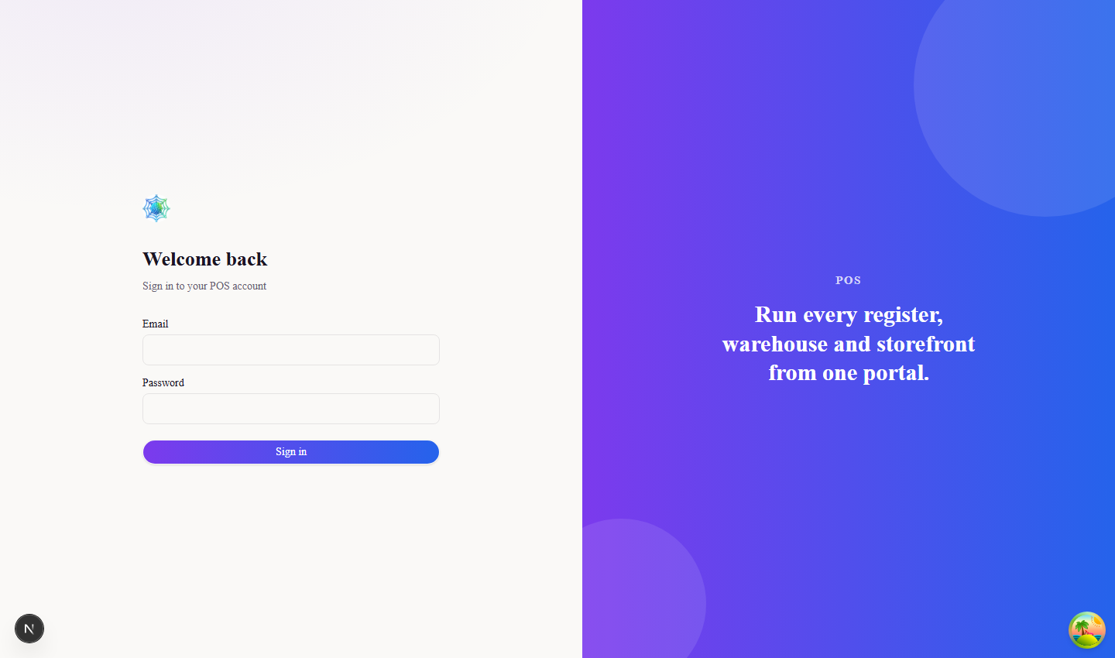
Figure 1. Sign-in screen

Selecting the financial year
After the password is accepted the system asks which financial year to work in. Every document created during the session is numbered against the year picked here, so confirm it is the running year before continuing.

Figure 2. Financial year selection, shown once per sign-in

3. Stores
A store is the top-level record everything else hangs from — stock, bills, staff and numbering all belong to one store. Open Stores from the sidebar to see the stores already set up.
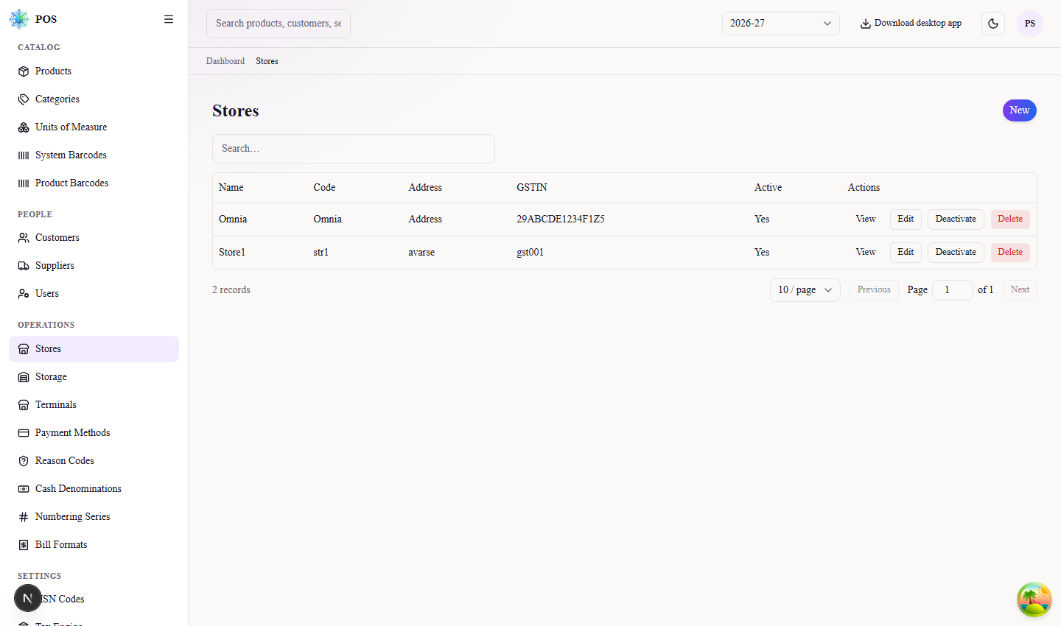
Figure 3. List of stores with their codes
Choose New to add a store. Name, address and store code are required. The store code is a short unique label such as str1 or str2; it must not repeat across stores, and it is the quickest way to tell two similarly named branches apart. Enter the GSTIN if the store is registered — the system checks the 15-character format and refuses anything that is not a valid GSTIN.
Saving a new store also creates its numbering series, its default bill and receipt formats, and one storage location named after the store. None of that needs to be set up by hand.

4. Storage locations
Storage is where stock physically sits. Each store starts with one storage location created automatically under the store's own name, which is enough for a single-room shop. Add more only when stock is genuinely held in separate places, such as a shop floor and a back godown.
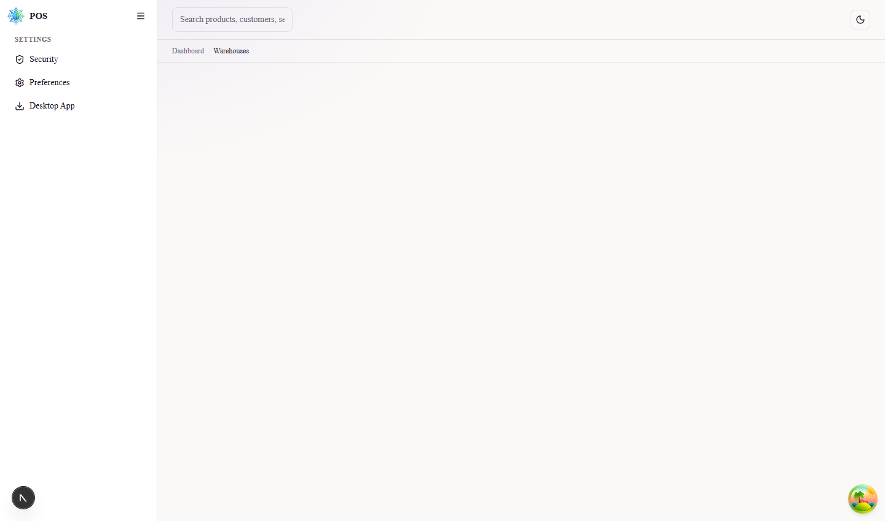
Figure 4. Storage locations for the selected store
Storage is deliberately restricted to the Super Administrator. Store staff select storage while entering stock, but they cannot create, rename or remove it.

5. Terminals
A terminal is a billing counter. Create one record per physical counter so that sales, shifts and cash counts can be traced back to the till they were made on.
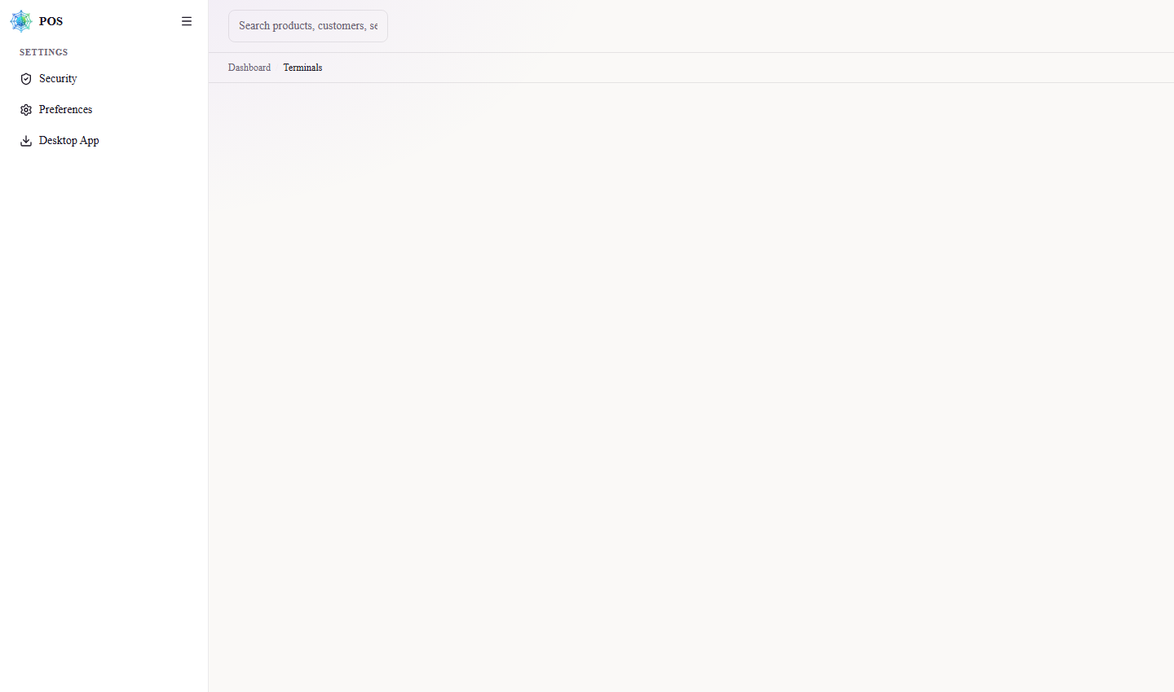
Figure 5. Terminals defined for the store

6. Numbering series
Numbering series decide how document numbers are built — the prefix, the financial year and the running count, for example CR/2027-28/16. A full set is created with the store, so normally there is nothing to do here beyond checking the prefixes suit the business.
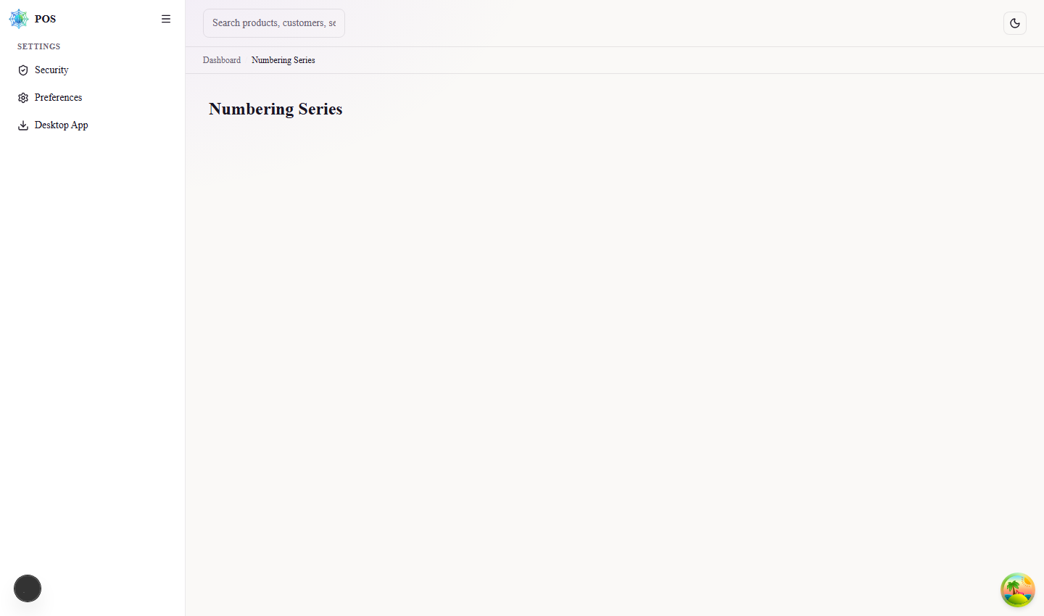
Figure 6. Numbering series for the selected store and year
The running number can be corrected here if records were removed directly from the database. Change it only when you are certain, because document numbers must never repeat.

7. Payment methods
These are the ways a customer can pay: cash, card, UPI and so on. Cash and the gateway methods are seeded automatically; add others only if the store really accepts them.
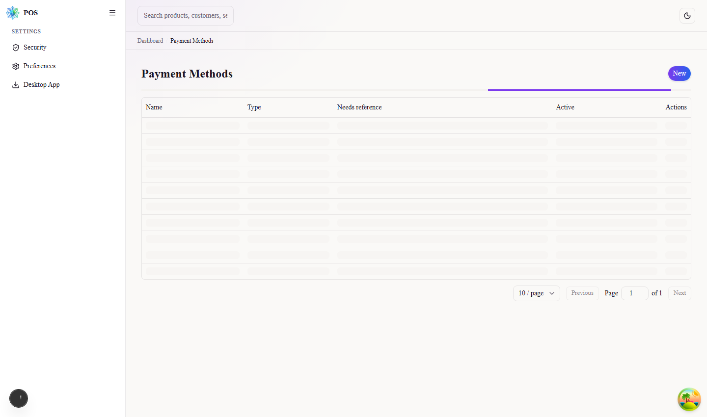
Figure 7. Payment methods available at billing

8. Reason codes
Reason codes explain why stock moved or why a bill was reversed. They appear in the drop-downs on damage, adjustment, block and return screens, which keeps the reporting consistent instead of leaving staff to type free text.
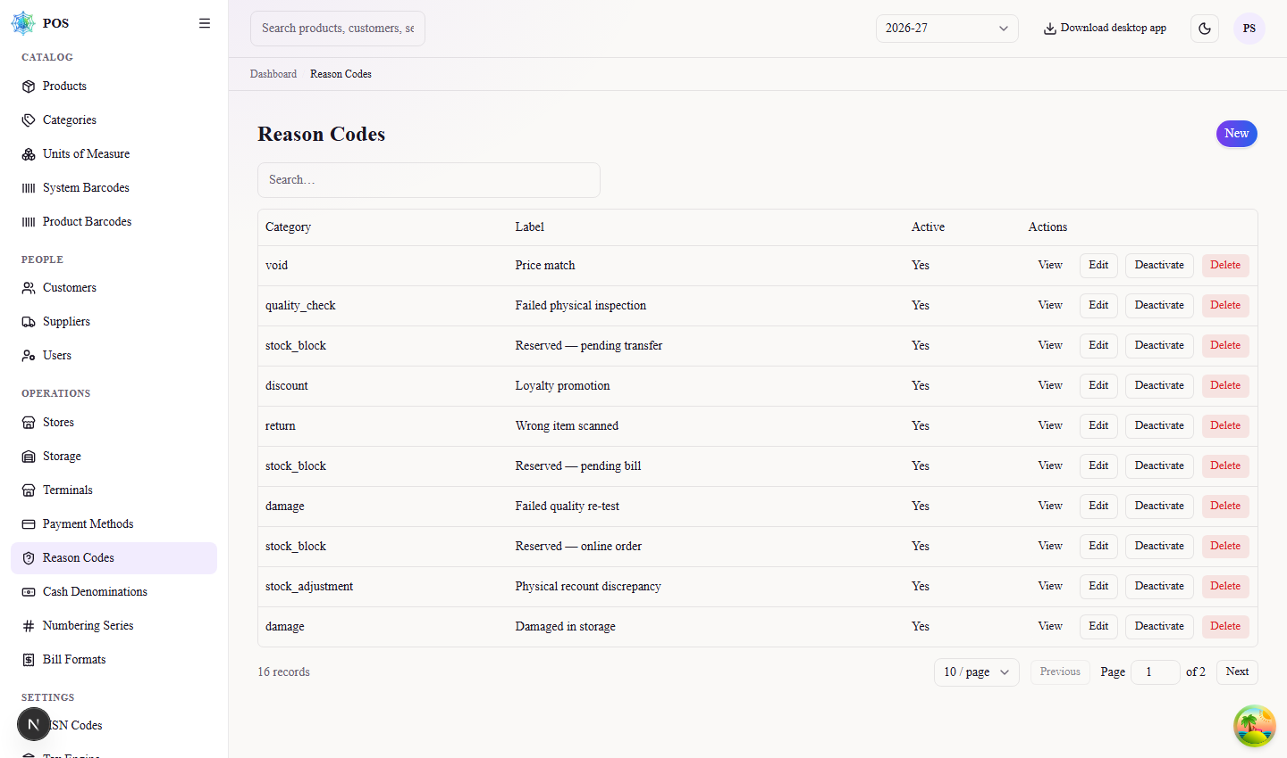
Figure 8. Reason codes grouped by category

9. HSN codes and tax
The HSN master holds each code with its CGST, SGST and IGST rates. Products point at an HSN code, and billing takes the tax rate from here, so the rates must be correct before the first bill is raised.
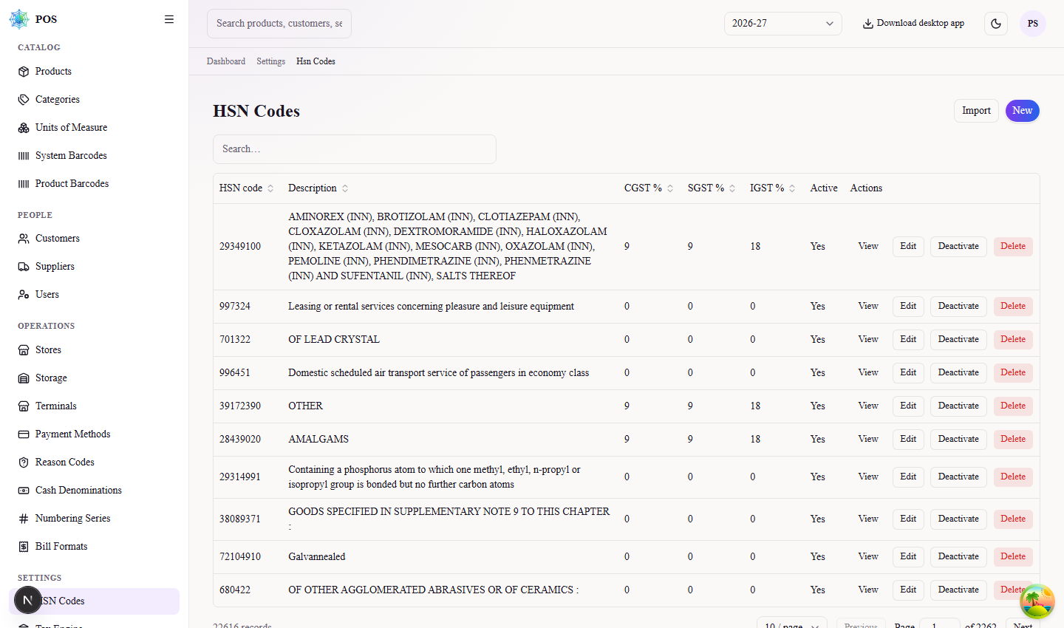
Figure 9. HSN code master with GST rates
Codes can also be brought in from a CSV file using Import, which is quicker than typing when a full rate list is available.

Tax engine
Each store is linked to a tax engine — India Standard for GST. Until a store is pointed at an engine, tax cannot be worked out on its bills, and staff see a reminder banner.
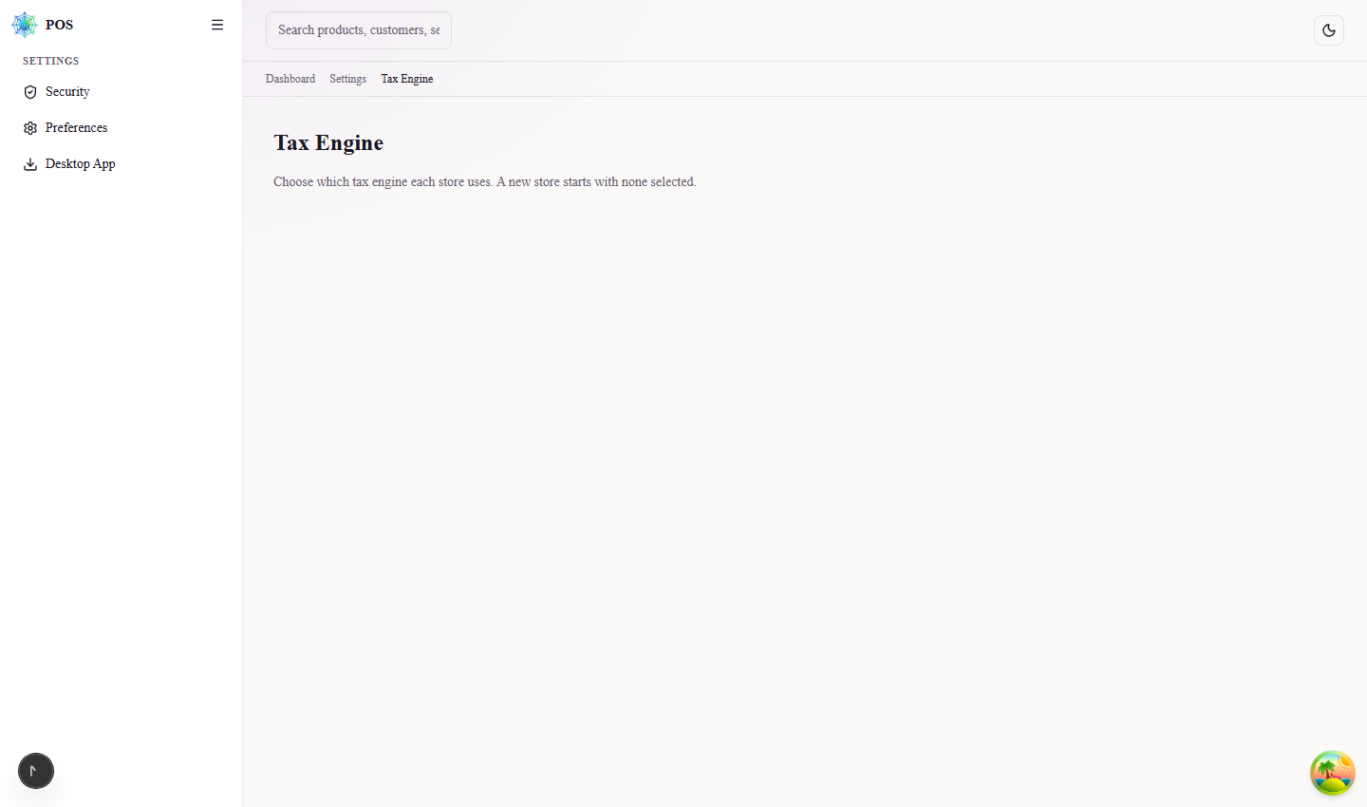
Figure 10. Tax engine selection per store

10. Bill formats
Bill formats are the printed layouts for bills, receipts, credit notes and refunds. A default set is created with every store and can be used as it is; edit them when the shop wants its own letterhead, footer or return policy on the print.
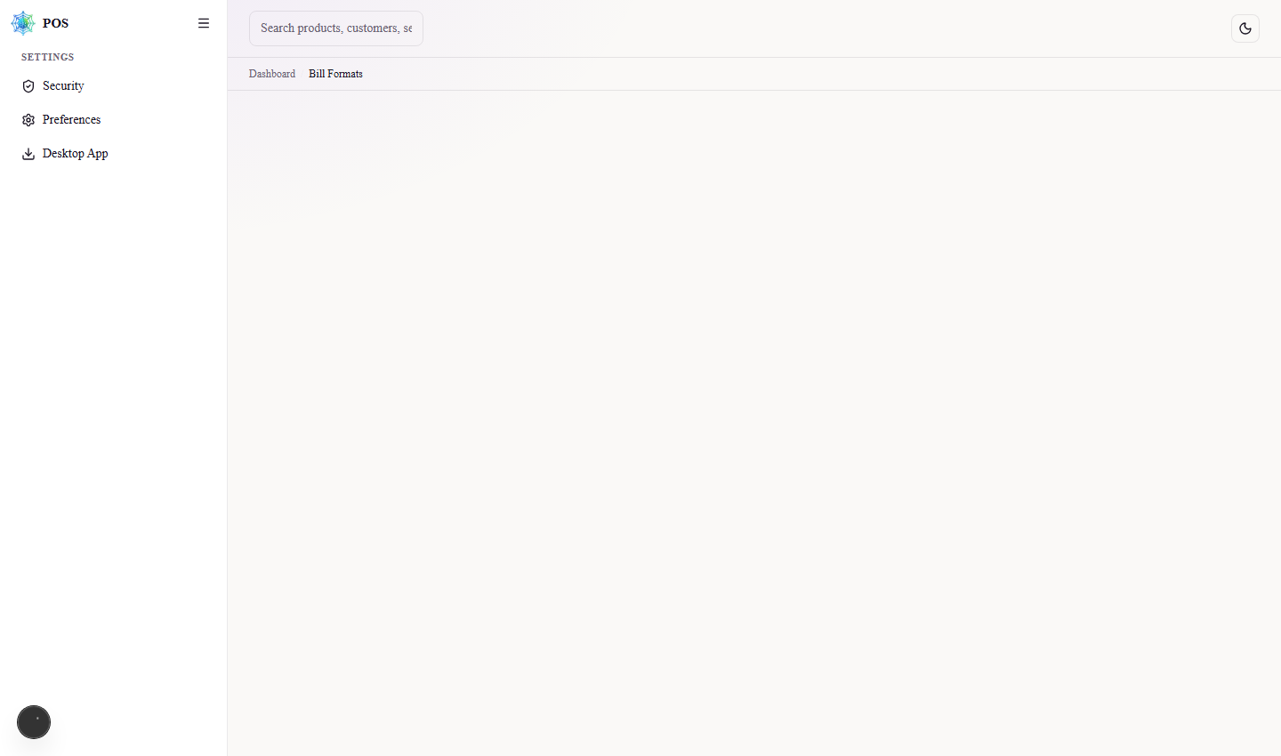
Figure 11. Bill and receipt formats by type and date
Formats are dated. A new format takes effect from its start date, and older documents keep printing on the layout that applied when they were raised.

11. Financial years
Financial years drive document numbering and every dated report. Add the coming year before it starts, so that numbering series can be prepared in advance and billing does not stop on 1 April.
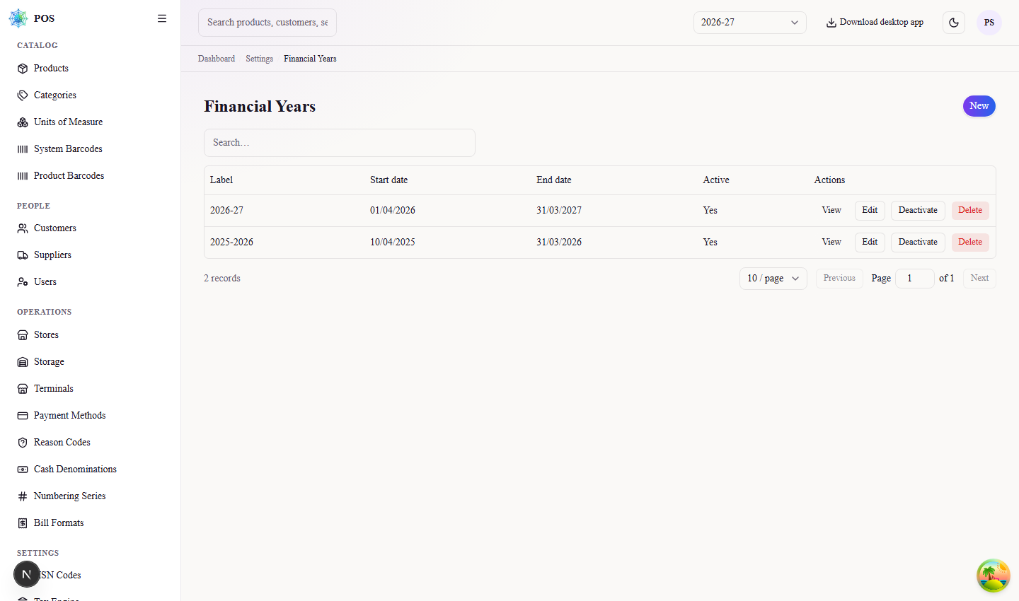
Figure 12. Financial years

12. Users
Create one user for each person who signs in. For a new store the first account to create is its Store Administrator; that person can then add their own cashiers and managers without coming back to you.
Choose New User, fill in the name, email and a starting password, set the role to Admin, and select the store. A user must belong to a store unless the role is Admin or above.
The account already created for the first store is:
Role | Email | Password | Store
Store Administrator | omnia-storeadmin@gmail.com | omnia@123 | Omnia

The Super Administrator role cannot be handed out from this screen by design. It is set directly on the database, which stops anyone from quietly promoting themselves.

13. Roles and rights
Four roles are supplied: Super Admin, Admin, Manager and Cashier. The rights grid shows exactly what each role may view, create, change and delete, and can be adjusted if a shop wants, say, its managers kept out of discounts.
Settings reserved for the Super Administrator are not listed in this grid, so they cannot be granted to a lower role even by mistake.

14. Online orders access
If the shop sells through a website, issue an API credential here. The secret is shown once at the time of creation and stored only as a hash, so copy it immediately and pass it to the website developer.

15. Desktop application
Counters normally run the Windows desktop build rather than a browser tab, because it can drive the receipt printer and cash drawer. Upload each new installer here and staff can download it from inside the application.

16. Handover checklist
Work through this before handing a new store to its administrator.
# | Step | Done
1 | Store created, with a unique store code and GSTIN
2 | Storage location confirmed (extra locations added if required)
3 | One terminal created per billing counter
4 | Numbering series checked for the running financial year
5 | Tax engine selected and HSN rates loaded
6 | Payment methods confirmed against what the shop accepts
7 | Bill and receipt formats checked on a test print
8 | Store Administrator account created and password handed over
9 | Desktop application installed on each counter

Once these are complete the store can open. Day-to-day work is covered in the Store Administrator Operating Guide.

